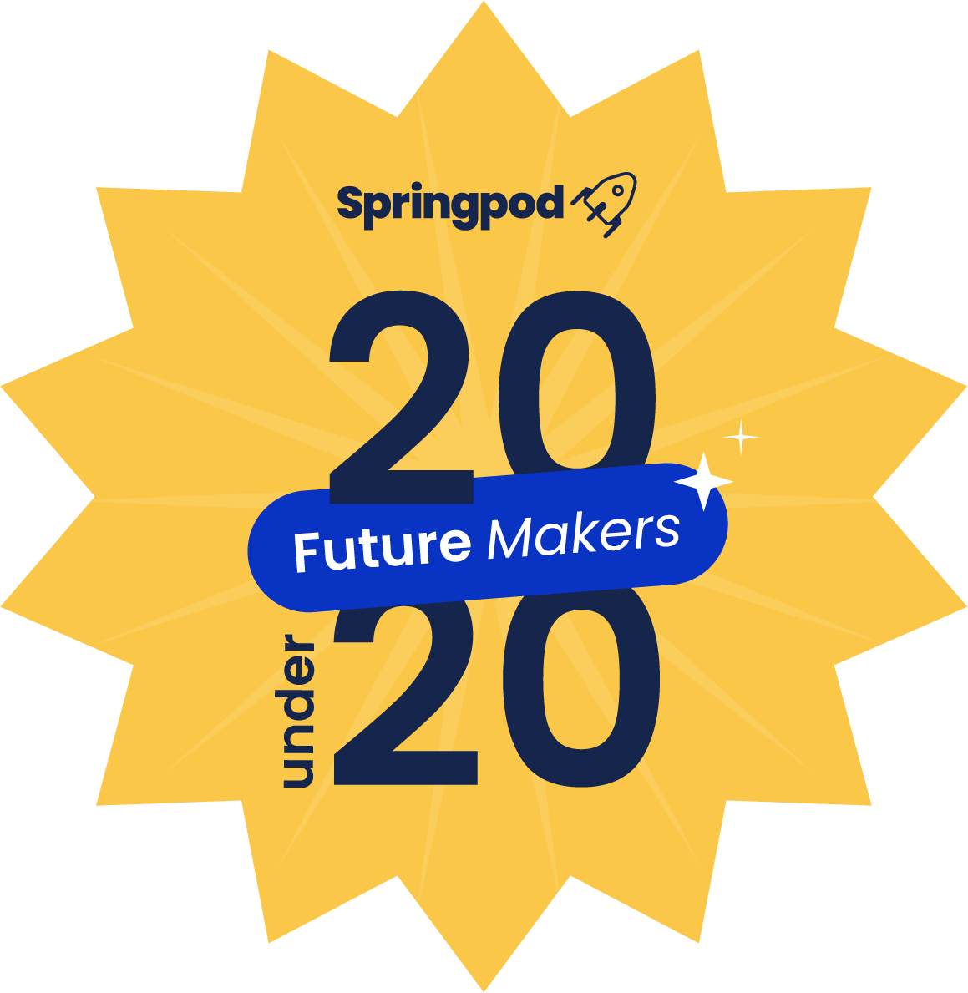

Future Makers: 20 Under 20 - Nomination Prep Pack
Recognising the most inspiring young people across the UK who are already reshaping the world of work, before they’ve even turned 20
This pack is your offline workspace - a place to gather key information and practise your answers before copying them into the official Typeform submission.
Purpose of The 20 under 20 list
The Future Makers: 20 Under 20 list recognises the most inspiring young people across the UK who are already reshaping the world of work, before they’ve even turned 20.
Whether you’re nominating yourself, a student, or a young person you know, this is your chance to showcase an impact that is meaningful, measurable, and inspiring.

Why nominate?
Being featured in 20 Under 20 provides:
🌟 National recognition – Your story, or the story of someone you nominate, will be shared across Springpod’s network of 100+ leading employers, educators, and community partners.
🌟 Inspiration for others – Highlighting achievements motivates peers and other young people to take action.
🌟 A personal brand boost – Recognition is valuable for CVs, UCAS applications, or early careers opportunities.
🌟 Awards celebration – Winners are invited to the Springpod Impact Awards in London, with travel and accommodation covered.
🌟 Free to enter – No costs involved; just share your story or nominate someone who’s making a difference!

Tips for a Strong Entry
- Be specific – Share clear examples of what you did and why it mattered. If you have numbers, great — but smaller wins count too.
- Show outcomes – Focus on what changed because of your actions. Did you inspire others? Improve something at school? Support your community? Create an opportunity for yourself that wouldn’t otherwise be available?
- Keep it clear – Respect word limits and keep answers simple, sharp, and easy to understand.
- Bring it to life – Use stories, quotes, or personal experiences. If you have photos or videos, you can share those too.

Why this pack?
The 20 Under 20 submission is hosted on Typeform. You cannot save and return later, so this prep pack allows you to:
- Review all questions in advance
- Prepare and polish your answers offline
- Copy-paste into Typeform when ready
Don’t forget the deadline for submission is Friday 26th September
Submission Preparation

Section 1. Contact details
First we will ask if you are nominating yourself or someone else. If you are nominating someone else we will need the contact details for both you and the young person you’re nominating. It is important to make sure you have permission from the young person to give us their contact information.

Next, we will ask for a couple of sentences summarising why you’re nominating yourself or another?
You can practise your answer below. Think about:

What they’ve done to make a difference for others: Mentoring peers, creating content, volunteering, leading projects, or opening doors in their community, school, industry or for themselves..

How their actions have helped people or communities: Friends, classmates, youth groups, schools, or wider audiences.

What makes them stand out: Leadership, creativity, resilience, initiative, or persistence.

Why their work matters: How they’re helping to shape the future of work or make opportunities more accessible.

Keep it short and punchy — 1–2 sentences is perfect.

Simple really, we just need to know your name, number, email and organisation.

Section 2. Learning about The Future Maker
- What area best describes the impact: Representing youth voice in early careers / Helping others prepare for their future (mentoring, workshops, peer support) / Challenging inequality in careers and access / Creating content that demystifies careers (blogs, videos, podcasts) / Driving change through experience (jobs, placements, volunteering) / Bringing opportunity to your community/ Making a brighter future for themselves (eg. completing multiple VWEX programmes, work experience, overcoming challenges, exploring options, or gaining new skills) / Other (multi-select)
- Who has benefitted from the work: Peers or classmates / The school, college, university or work community/ The local community or a youth group / A wider industry or a national impact / The nominee themselves (personal growth, completing programmes, gaining skills, overcoming challenges, or exploring opportunities) / Other (multi-select)

Section 3. Self-Assessment (with justification)
The following section is a self-assessment section where we are asking you to rate your involvement in four core areas.

Please rate yourself (or the young person you're nominating) honestly. The scale is measuring maturity, not ambition. Your example matters more than the number you rate.
(Practice your answers here - you’ll need to give a rating 1–5 and a short justification for each. Max 600 characters per justification in.
Scale:
1 – Just starting: Early steps taken, limited reach or influence.
2 – Finding your feet: Some activity completed, small but growing impact.
3 – Making progress: Consistent action with clear evidence of impact on peers, community, or yourself.
4 – Well established: Strong, sustained impact that benefits multiple people or significantly improves opportunities - including achievements for yourself.
5 – Leading the way: Exceptional, innovative, wide-reaching impact with long-term influence on others or yourself.
Areas to rate & justify:
Area | Description | Rating | Justification
Helping others prepare for the future | How much have you/they supported peers to get career-ready, learn new skills, or gain confidence?
Challenging inequality & opening access | How much have you/ they broken down barriers, created fairer opportunities, or helped underrepresented groups access new pathways?
Creating content or inspiring peers | How much have you/ they used creativity - blogs, videos, social media, projects - to explain careers, share insights, or motivate others?
Driving change through experience | How much have you/ they turned their experiences, placements, or volunteering into positive change for themselves or others?

Section 4. Story telling
(Practice your narrative answers here — paste final version into Typeform later)
Describe one or two concrete actions ﻿﻿you/ they have taken to create impact and reshape the world of work? (1,200 characters max)
Proudest achievement this year? (1,200 characters max)
This could be anything from an innovative new initiative to a personal milestone reached. Focus on what they’ve done and the difference it made.

Section 5. Looking forward
- In one sentence, what do you/ they ﻿﻿hope to achieve in the next 12 months to expand your/their impact (500 characters max)

Section 6. Supporting Evidence (optional)
- Anything else you’d like to add? (Such as stories, links, testimonials, case studies, or media). This is a long text box question so feel free to paste any supporting materials here
- We would love to include a photo of the young person nominated on the list if included! If comfortable, please attach a photograph alongside any other docs you'd like us to review
Final Step: Once your answers are polished, copy them into the official Typeform. Only Typeform submissions will be considered > https://springpod-survey.typeform.com/to/joUZmaPA


